Part Number: PT942-0C180

Kit Contents
Item # | Quantity Reqd. | Description
1 | 1 | Molding, LH Front Door
2 | 1 | Molding, LH Rear Door
3 | 1 | Molding, RH Front Door
4 | 1 | Molding, RH Rear Door
Hardware Bag Contents
Item # | Quantity Reqd. | Description
1
2
Additional Items Required For Installation
Item # | Quantity Reqd. | Description
1
2
Conflicts
None
Recommended Tools
Personal & Vehicle Protection | Notes
Safety Glasses
Vehicle Protection
Special Tools | Notes
Non intrusive Infrared Temp Probe/Gun
Installation Tools | Notes
Tailors Tape Measure
Masking Tape | 2” wide
Clean Lint-free Cloths
Straight Edge (Plastic)
Heat Gun (if required to warm surfaces)
Special Chemicals | Notes
VDC Approved Cleaner
General Applicability
Sequoia Limited and Platinum
Recommended Sequence of Application
Item # | Accessory
1 | Body Side Molding
*Mandatory

Vehicle Service Parts (may be required for reassembly)
Item # | Qty Required | Description
PT942-0C180-RH | 1 | Moldings, RH side
PT942-0C180-LH | 1 | Moldings, LH Side
Legend
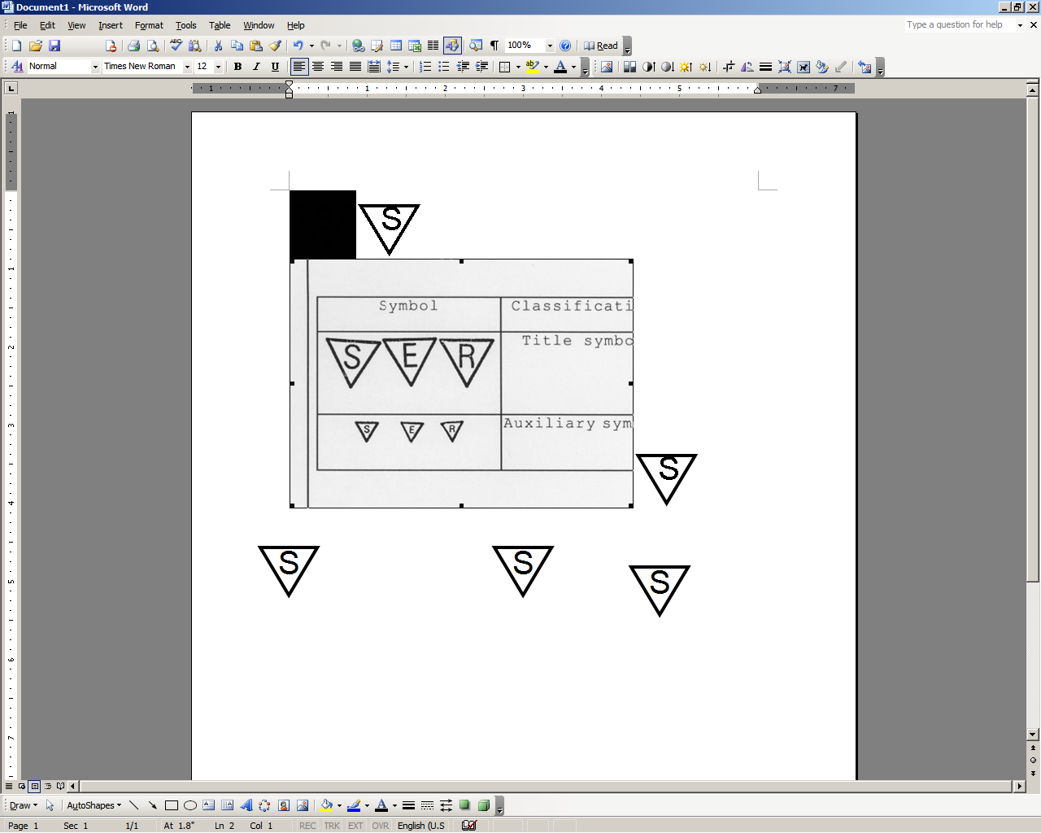




STOP: Damage to the vehicle may occur. Do not proceed until process has been complied with.
OPERATOR SAFETY: Use caution to avoid risk of injury.
CAUTION: A process that must be carefully observed in order to reduce the risk of damage to the accessory/vehicle and to ensure a quality installation.
TOOLS & EQUIPMENT: Used in Figures calls out the specific tools and equipment recommended for this process.
REVISION MARK: This mark highlights a change in installation with respect to previous issue.

SAFETY TORQUE: This mark indicates that torque is related to safety.

Care must be taken when installing this accessory to ensure damage does not occur to the vehicle. The installation of this accessory should follow approved guidelines to ensure a quality installation.

These guidelines can be found in the "Accessory Installation Practices" document.

This document covers such items as:
- Vehicle Protection (use of covers and blankets, cleaning chemicals, etc.).
- Safety (eye protection, rechecking torque procedure, etc.).
- Vehicle Disassembly/Reassembly (panel removal, part storage, etc.).
- Electrical Component Disassembly/Reassembly (battery disconnection, connector removal, etc.).

Please see your Lexus dealer for a copy of this document.

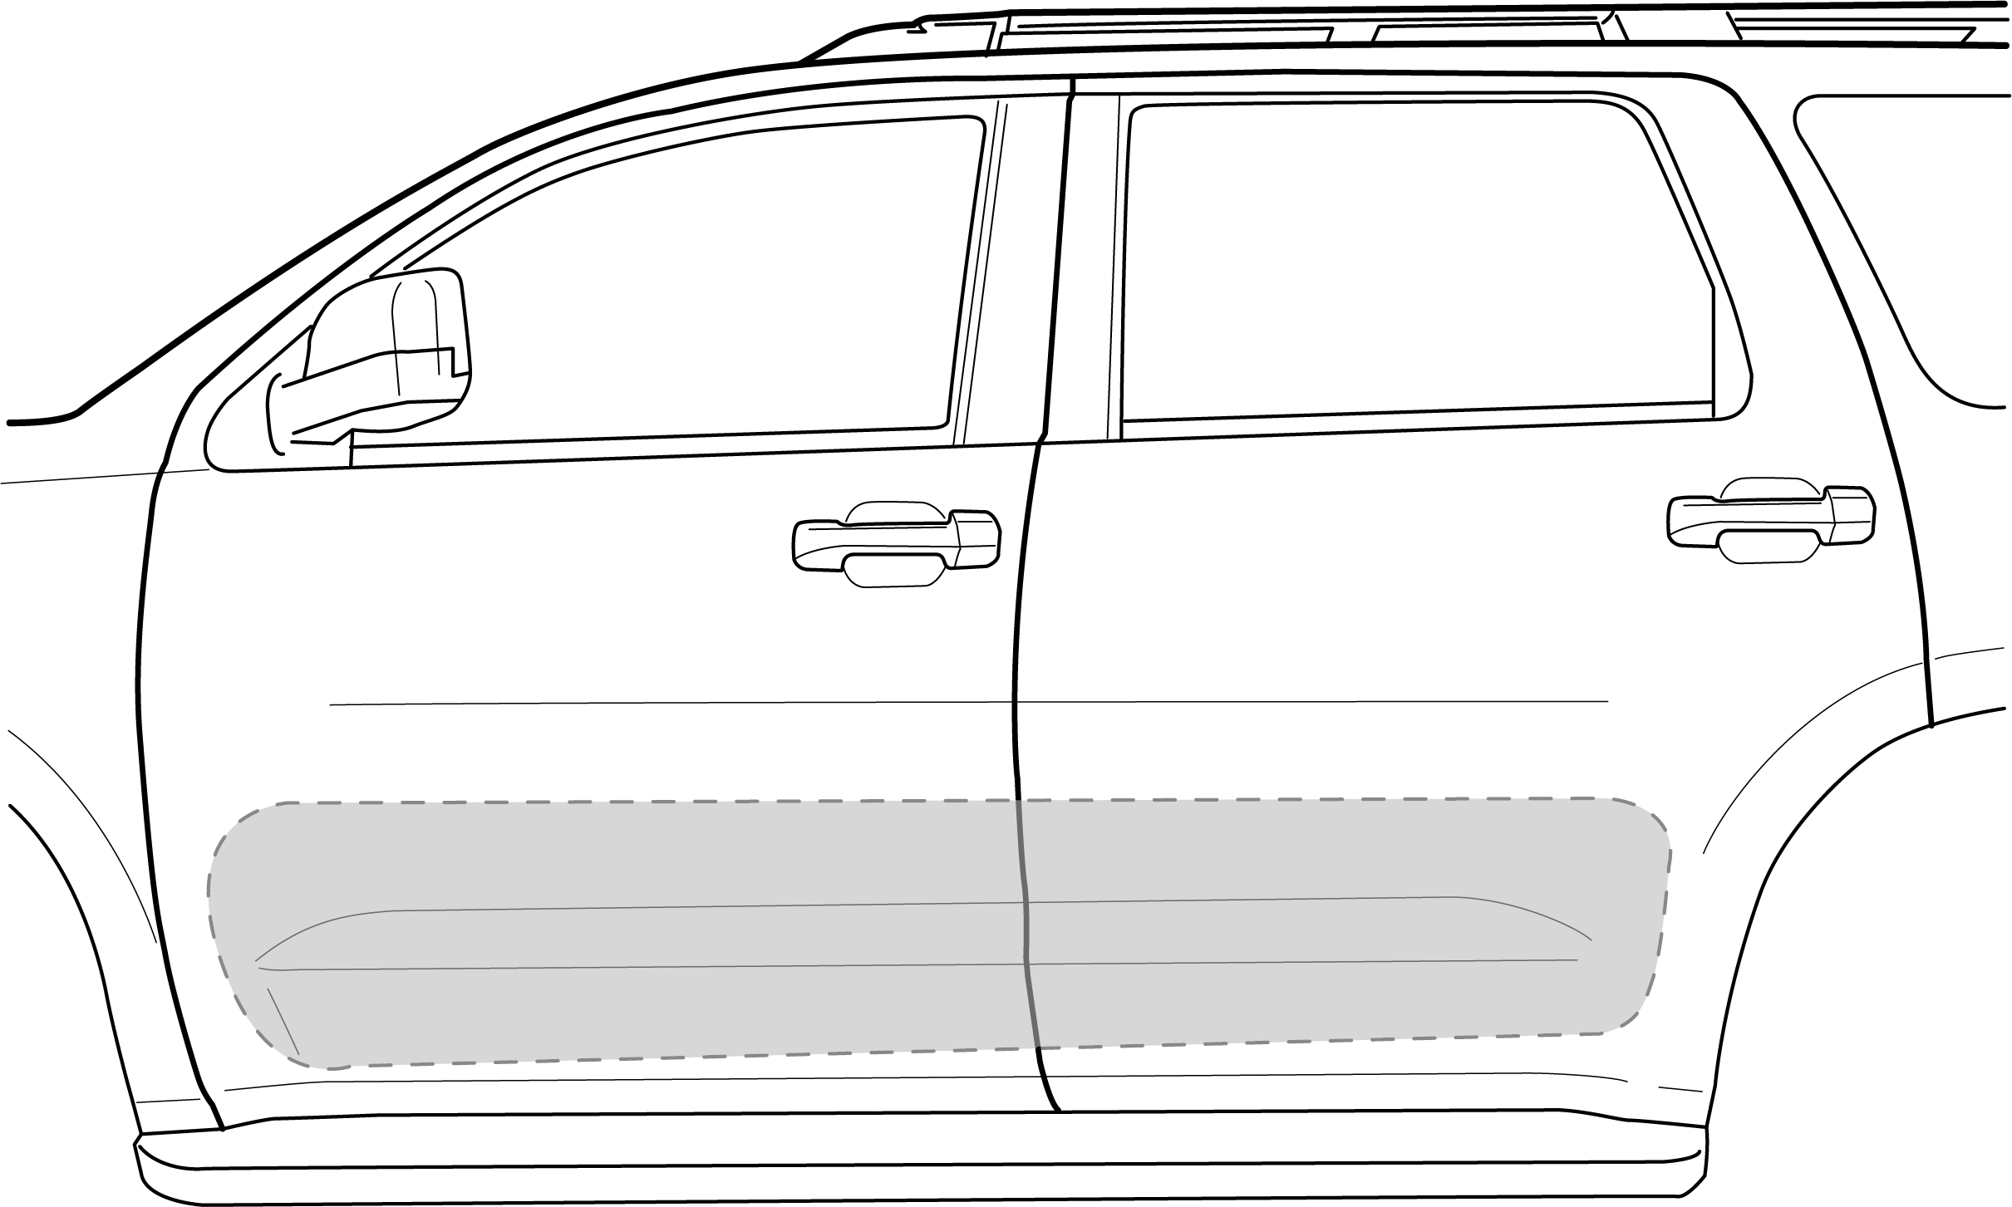
Vehicle Preparation
  - The work area, body side moldings, and vehicle door surface temperatures must be at least 60˚F.
  - Saturate a clean lint-free cloth with VDC approved cleaner and clean the areas of each door as shown in Fig. (1-1).
    - When cleaning with VDC approved cleaner, follow the manufacturer’s directions. Do not allow cleaner to air dry.
Fig.1-1
  - Wipe the cleaned surfaces with a clean, dry, lint-free cloth.
NOTE: Once cleaned do not contaminate this surface by touching it with your bare hands.

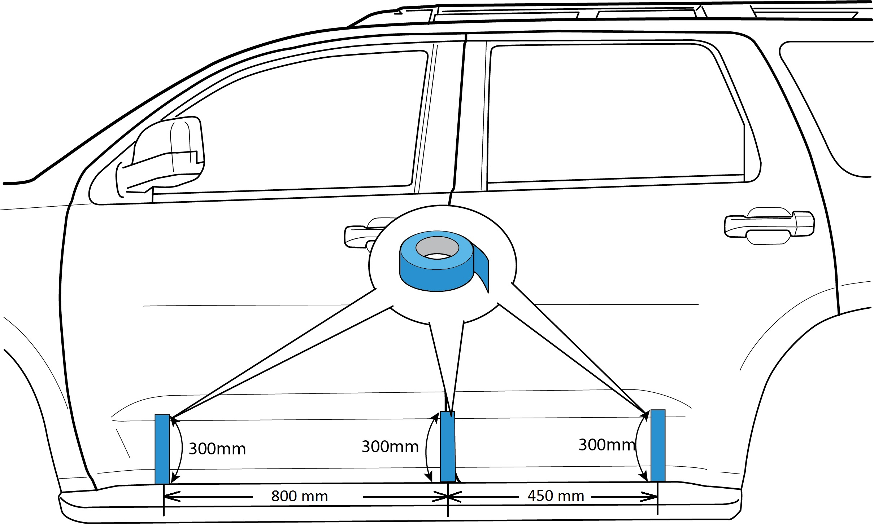
Alignment Tape Application
Fig. 2-1
  - Measure 800mm forward from the bottom rear edge of the front door and place a vertical piece of tape on the front door approximately 300mm long. Place a vertical piece of tape near the door gap between the front and rear doors approximately 300mm long. Measure 450mm rearward from the front bottom edge of the rear door and place a vertical piece of tape on the rear door approximately 300mm long.
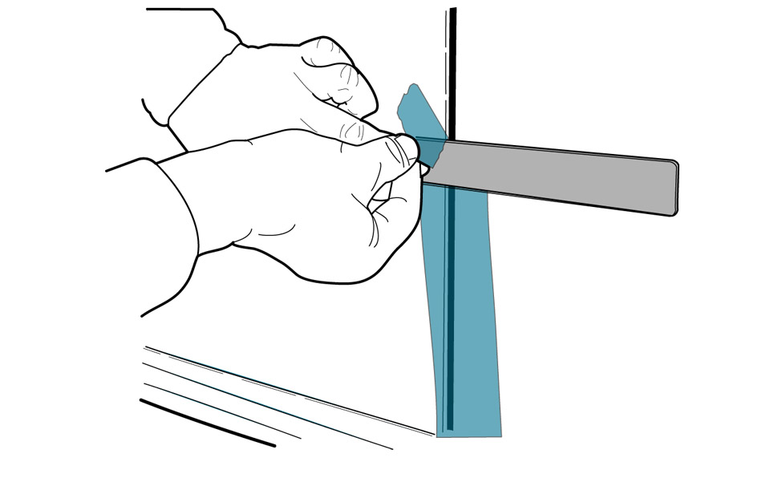
  - Measure up from the bottom of the door edges 237mm and place a horizontal mark on the three vertical pieces of tape and using a straight edge, tear the vertical tape along a horizontal line at the upper mark as shown in Fig. 2-2 & Fig. 2-3.
Fig. 2-2

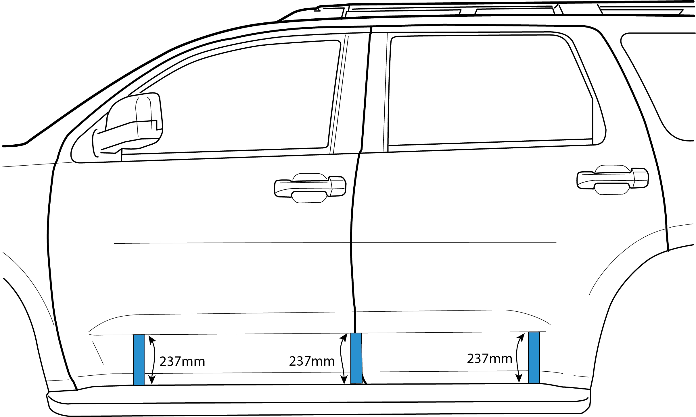
Fig. 2-3

  - Repeat Steps 2(a) to 2(c) for the other side of vehicle.

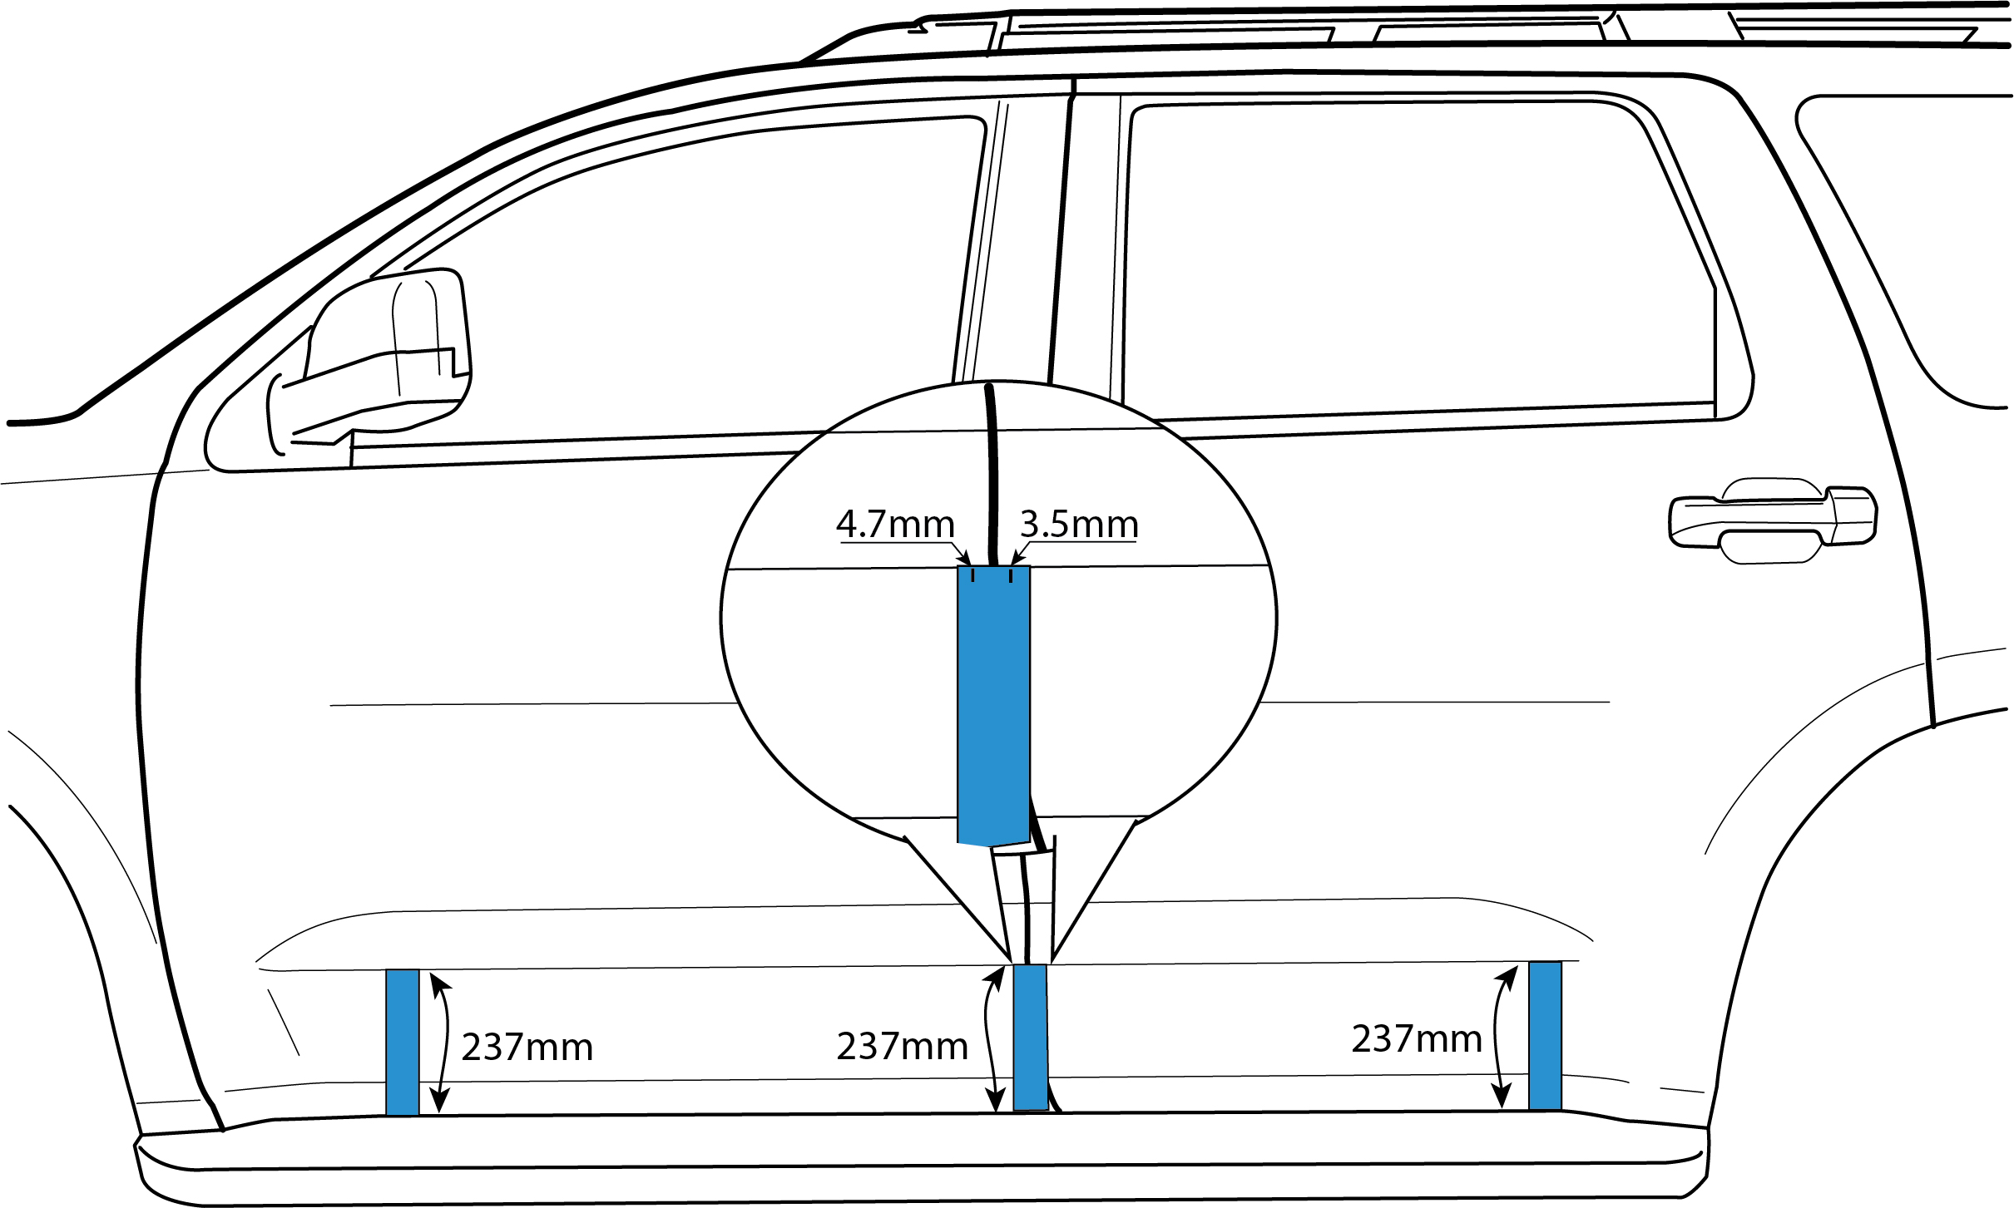
  - Place a mark on the tape 4.7mm forward from the front door edge and 3.5mm rearward from the rear door edge as shown in Fig.2.4
Fig. 2-4

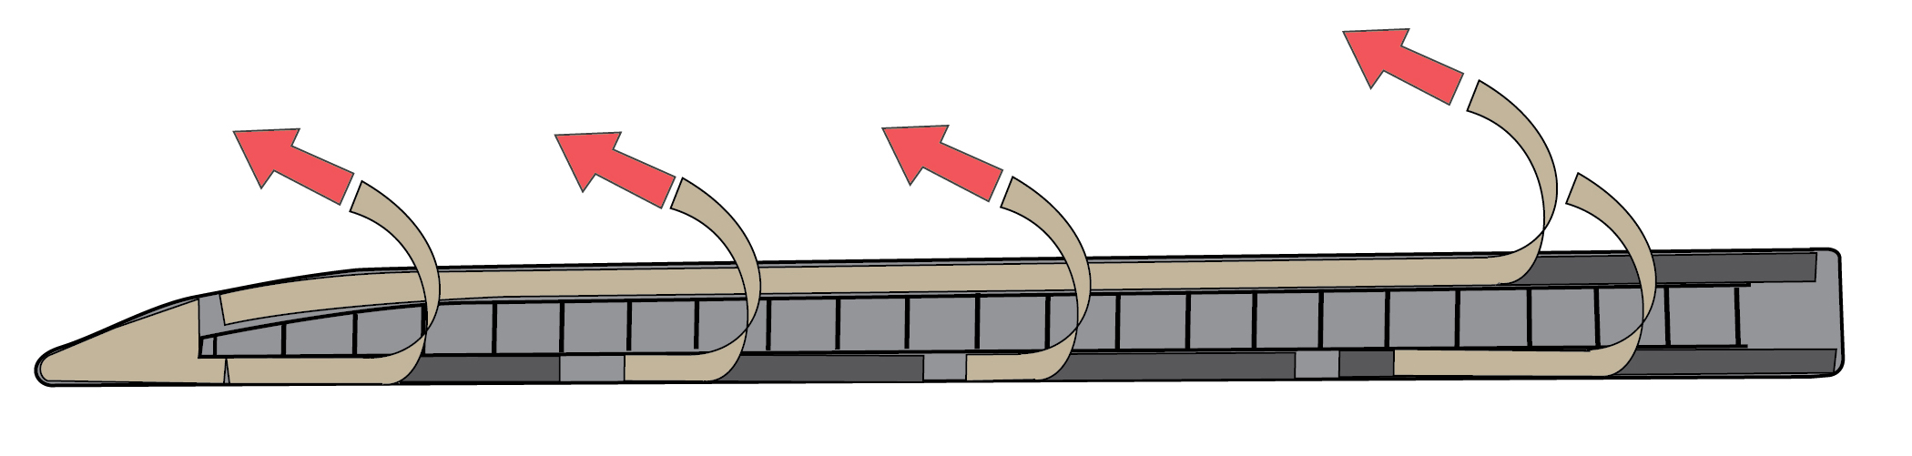
- Body Side Molding Installation.
  - On the inside of each of the four moldings is identified as to their correct position on the vehicle. Start with the LH front door molding. While carefully holding the molding by its edges, partially pull the plastic tape at the end of the part to release liner from the acrylic foam tape strips. Do not fully remove the liner from the tape (Fig. 3-1)
Fig. 3-1
NOTE: Once the release liner is removed from the molding, the surface of the foam tape must not be touched!

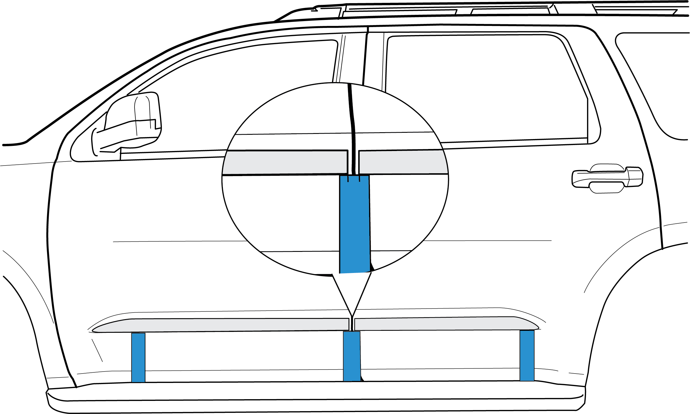
  - Hold the molding about 12mm from the surface of the front door, align the rear edge of the molding to the 4.7mm mark placed on the tape at the door gap and align the bottom of the molding to the top edge of the two pieces of tape on the door as shown in Fig. 3-2. The rear bottom edge of the molding aligns vertically with the top edge of the vertical tape strip. The front portion of the molding aligns with the top edge of the tape strip at the front of the door. Once the molding is properly aligned, lightly press it to the door surface starting at the bottom rear and working toward the front while removing the remaining tape liner. Do not allow both ends to contact and stick to the door before the center contacts.
Fig. 3-2

  - Repeat steps 3-a and 3-b for the LH rear door molding placing the front edge of the molding to the 3.5mm mark in the tape from the door edge as shown in Fig. 3-2
RH Rear Molding
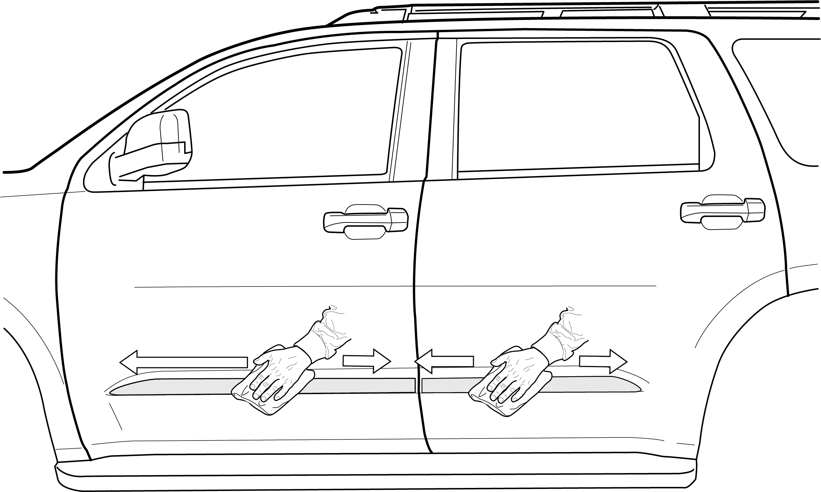
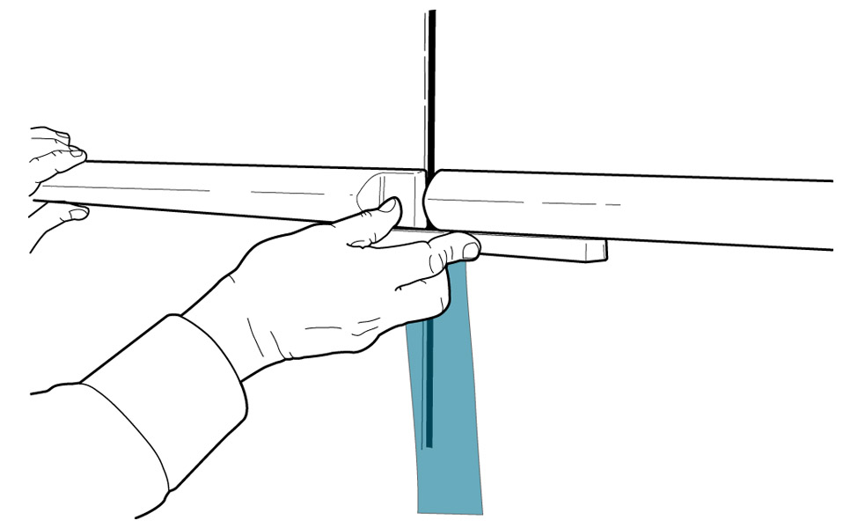
NOTE: A good way to ensure that where the rear and front molding meet between the doors align vertically is to hold a plastic straight edge against the bottom of the front molding and use it as a guide for the rear molding as shown in Fig. 3-3. Tolerance for alignment in the vertical direction of the front and rear molding in relation to each other is 0.0mm +/-1.0mm
Fig. 3-3
Fig. 3-4
  - Using clean cloth apply firm pressure (approx. 15lbs) around the perimeter of the parts to ensure complete adhesion of the tape to the door surface. (Fig. 3-4)
  - Repeat steps 3b-3d for the RH side of the vehicle.

Accessory Function Checks
Check visual alignment

Check for proper tape adhesion.

Vehicle Function Checks
None Required

Vehicle Appearance Checks
After accessory installation and removal of protective cover(s), perform a visual inspection.

The moldings should be visually straight.
The front edge of the rear moldings should be 4.7 mm away from the front edge of the rear door.
The inside rear edge of the front moldings should be 3.5 mm away from the rear edge of the front doors.

Confirm 100% tape adhesion completely around the part between the Body Side Molding and door sheet metal.

Ensure no damage (including scuffs and scratches) was caused during the installation process. (For PPO installation, refer to Accessory Quality Shipping Standard.)

